|  |  |  |
| --- | --- | --- |
| Name / ID no. | Contact | Responsible for |
| She Kam Hung 105025 | timmyshe@gmail.com | Plot Planning  Code Editing  Graphic Production  SFX Selection |
| Siu Hang Nam 105041 | charmainesiucs@gmail.com | Initial Idea  Plot Planning  BGM Selection & Editing  Defect Checking |
| Hui Kun Lam 105168 | rhkl.ssc@gmail.com | Audio Code Development  Code Editing |

TEXT CONTENT

|  |  |
| --- | --- |
| Story Title | **水晶 A Tale of Crystal** |
| Journey Origin | Title:水晶  BGText1.png |
| Journey Destination | Text: Fin  Graphic83.png |
| No. of Moments | 84 |
| Text Segments | *As Attached Separately: Item Plot.xlsx* |
|  |  |
|  |  |
|  |  |

VISUAL STRUCTURE : STORYBOARD

|  |  |
| --- | --- |
| Moment 1 | Text Segment:  對故鄉的記憶，只剩無盡的火焰……  Other Description:  It is a scene when the character really start having a move. It explained action s the character took afterwards.  As it is a sorrow scene, the visual was filled with darkened graphic.  Also, the BGM picked in the scene was one with taste of sorrow. |
| Moment 2 | Text Segment:  對故鄉的記憶，只剩無盡的火焰……  Other Description:  It is a scene when the character really start having a move. It explained action s the character took afterwards.  As it is a sorrow scene, the visual was filled with darkened graphic.  Also, the BGM picked in the scene was one with taste of sorrow. |
| Moment 3 | Text Segment:  想的就跟上。  Other Description:  It is a scene when the character met a person who changed his life, his master, both psychically, and physically.  It is an important turning point of the character. |
| Moment 4 | Text Segment:  要走了嗎？  Other Description:  This scene is another turning point of the story, when the character had prepared himself to claim from the governor what was being owed, his parents’ life.  This scene was matched up with a tensed BGM, which is used to give the reader a feeling that the character was leading a hard time during his ‘preparation’. |
| Moment 5 | Text Segment:  這次不知又要死多少人。  Other Description:  This scene was put here to provide a reason for the decision making of the character at the end.  And it strength the character’s determination to defeat the governor, as the conversion reminded him his horrible memory to the village he was born. |
| Moment 6 | Text Segment:  N/A  Other Description:  Crow was used as transition from the long shot of the castle to the door of it. The reason of using crow, which usually imply inauspicious, was to tell the readers it is a situation of uncertainty, the future facing the character may not be so prosperous.  Followed by the first fighting shot of the story, which is the first real obstacle the character faced, the BGM chosen was of a speedy pace, with a feel of dangerous. |
| Moment 7 | Text Segment:  已經消逝的生命，已經不會回來了。  Other Description:  It is the most important scene in the story. It can be easily noticed that the text above had been mention for the third time. It was actually the value of the story. This statement was told by his master, and helped him to make a sensible decision facing the temptation of the governor.  The whole scene was matched up with a BGM with a feel of heroic, however a taste of sad |
| Moment 8 | Text Segment:  Fin  Other Description:  This is the last scene of the story. Thanks to the character, the land had recovered to peace. It is a very fairy tale- style to end a story, but happy endings are always welcome, which imply the painful decision the character made was correct. |

VISUAL STRUCTURE : LAYERS

Foreground:

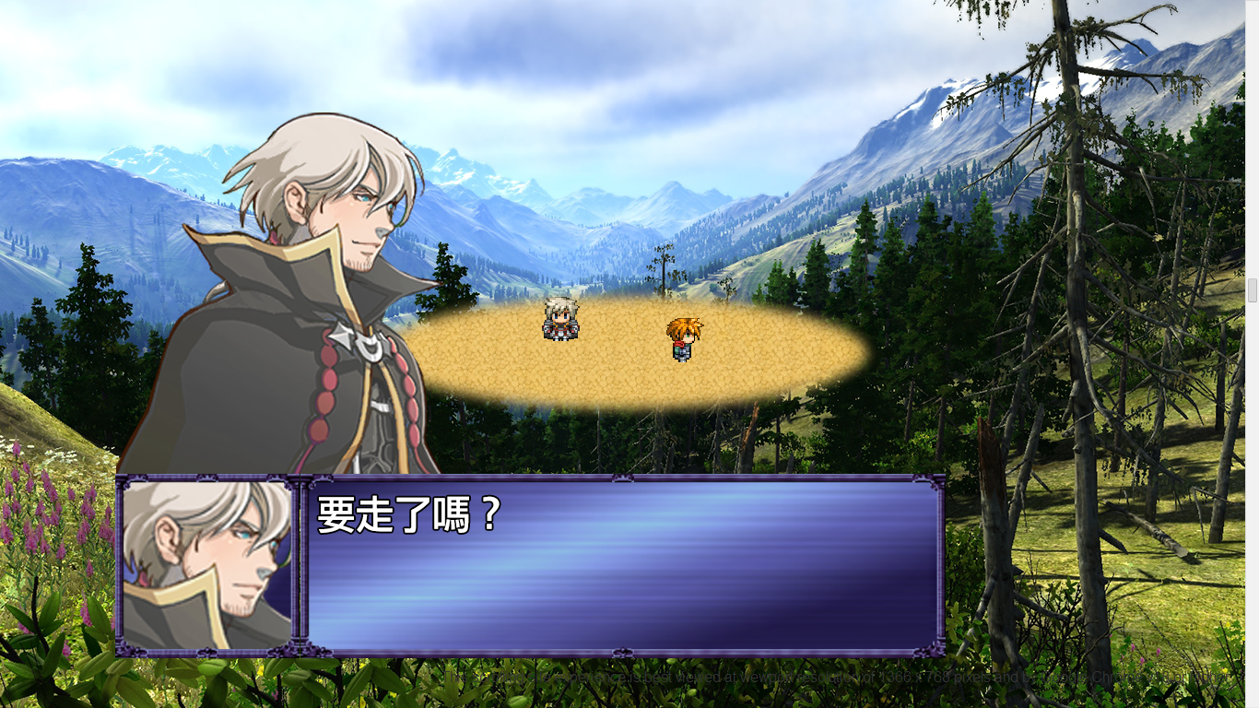



As the story was presented in the way of a game, the dialog box was always the foreground of this scrolling story, which provides the readers information about the development of the story.

Background:

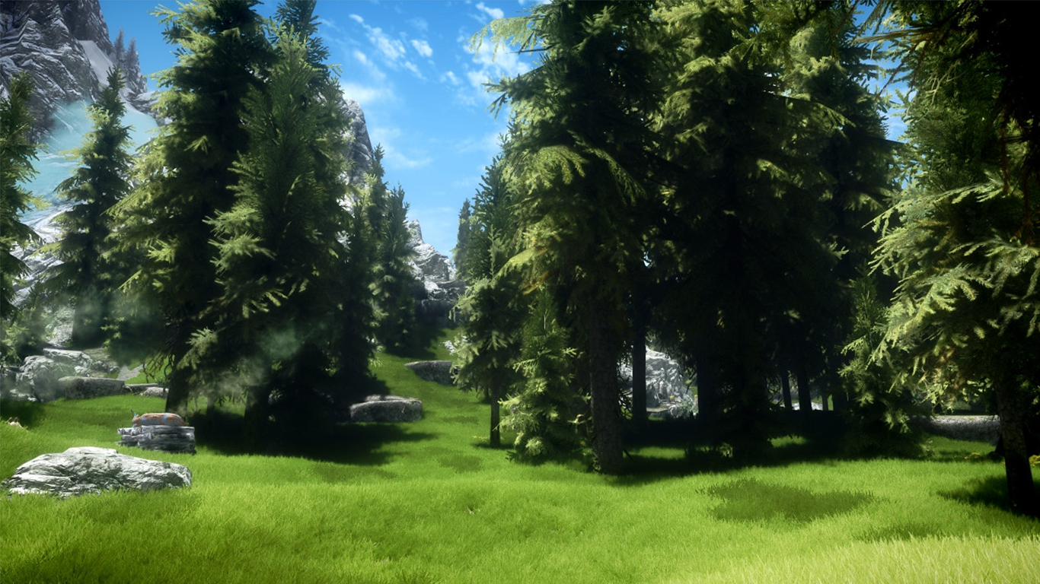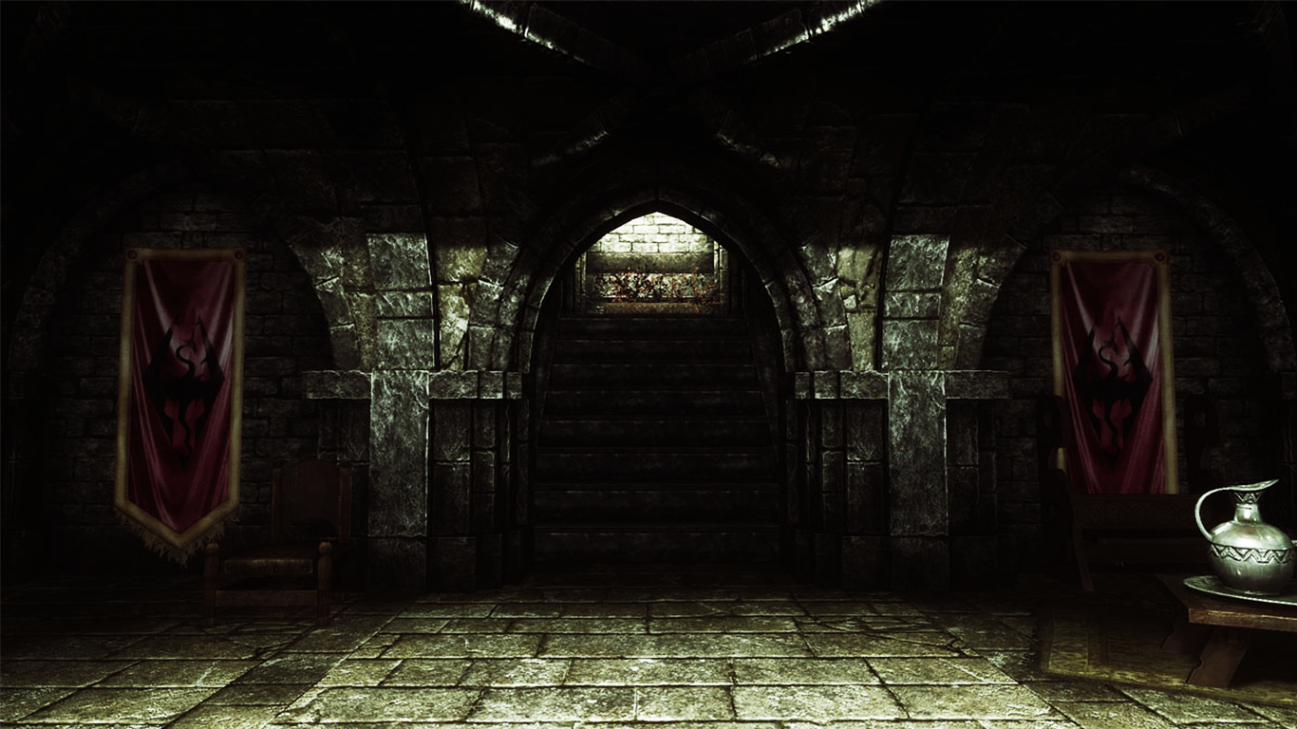

Background changes according to the development of the story. Most of the time the backgrounds are indicating the location of the character.

Midground:

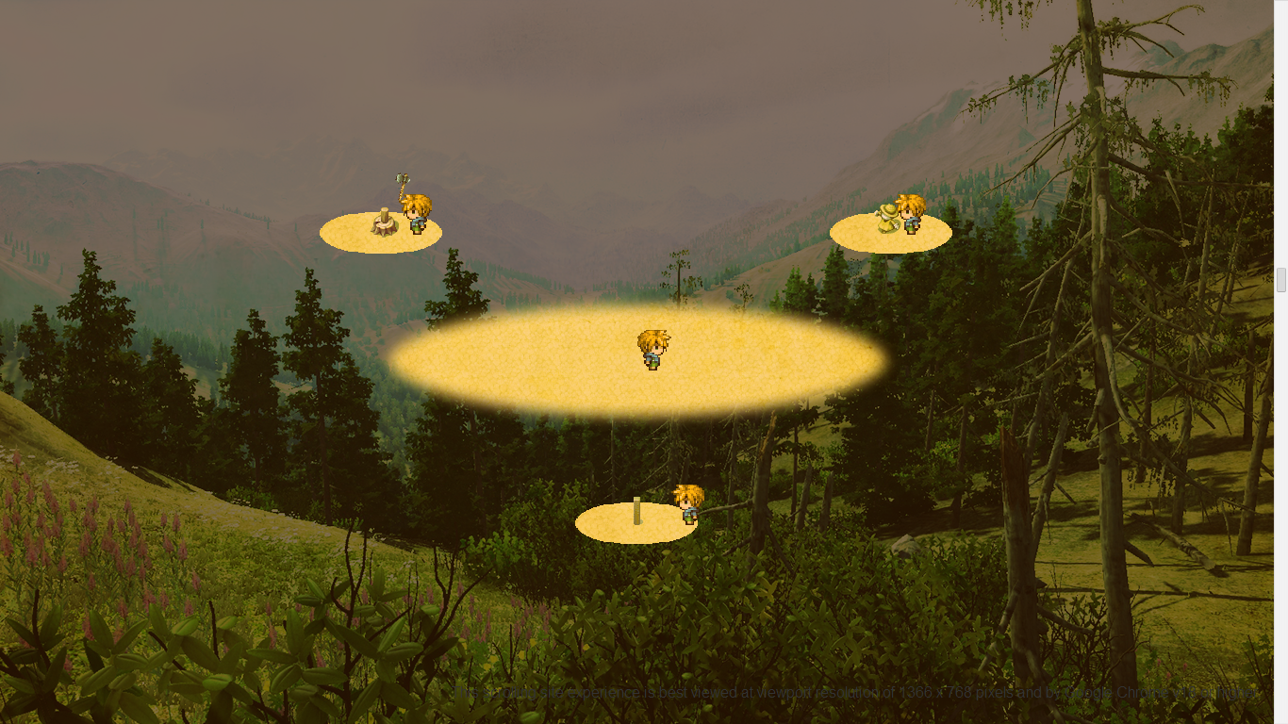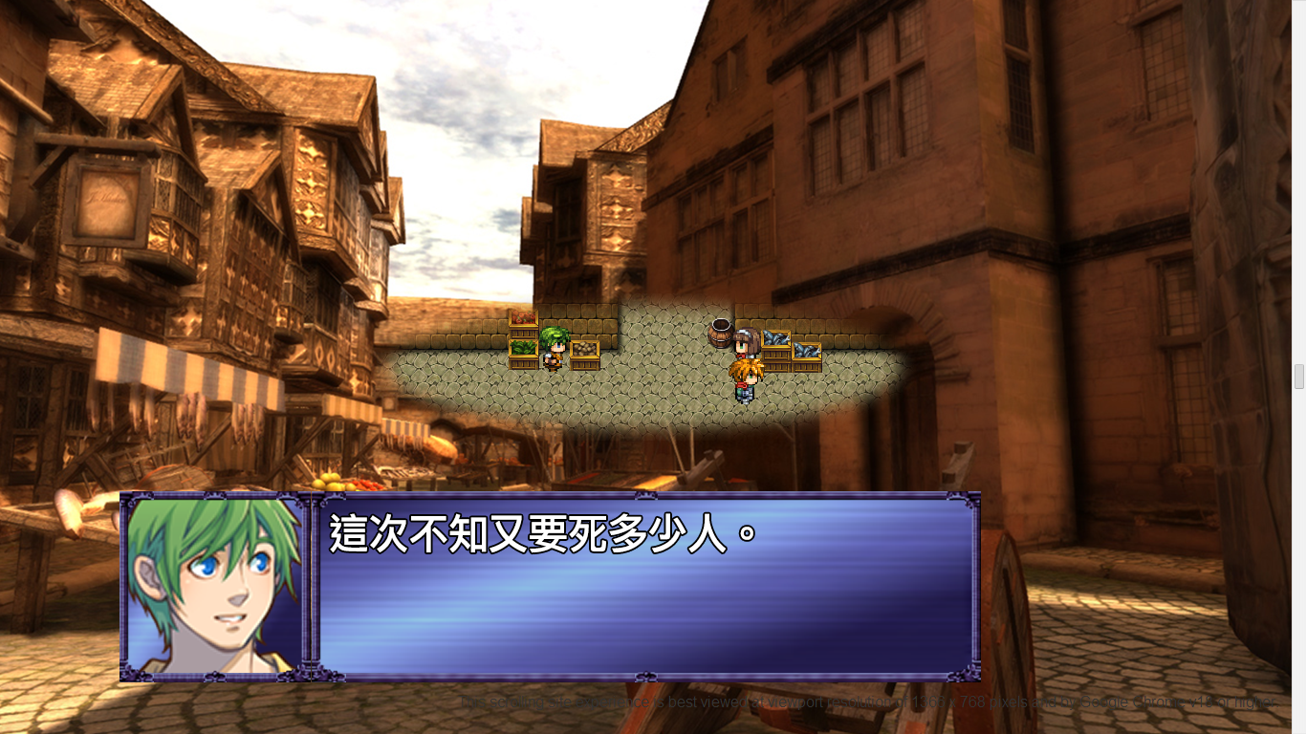

In this story, the midground is the place where the main events happens. It shows, visually, what the character was doing, and where was he going.

This midground is purposely chosen to be the stage of main event, as it located at the center of the visual area, and readers can focus on it, and always on it, as the midground never relocate.